Testing the Spacetime Unified Substrate Configuration Theory at Galactic Scales: From Rotation Curves to the Radial Acceleration Relation
Abstract
This paper presents a systematic observational test of the core prediction of the Spacetime Unified Substrate Configuration Theory. The theory proposes that spacetime is a continuous medium, and its first-order phase transition from an extended state to a contracted state manifests as a critical acceleration a0​≈1.2×10−10 m/s2 at galactic scales, which is the origin of gravitational anomalies commonly attributed to dark matter. To verify this hypothesis, we use the publicly available SPARC galaxy database to conduct rotation curve fitting and Radial Acceleration Relation (RAR) analysis sequentially. With a0​ fixed and no additional free parameters introduced, the analysis of 2693 independent data points from 153 galaxies shows that the median ratio of theoretical predictions to observed accelerations is 0.976, with a logarithmic scatter of only 0.133 dex, consistent with the inherent noise level of the data and showing no systematic bias. This result provides direct quantitative observational support for the spacetime phase transition theory and confirms its validity at galactic scales.

1. Theoretical Core and Testable Predictions
The Spacetime Unified Substrate Configuration Theory abandons the dark matter particle hypothesis and attributes gravitational anomalies at galactic scales to the intrinsic dynamic behavior of the spacetime substrate. The universe itself is a continuous medium; in the low-acceleration regime at the outskirts of galaxies (g≪a0​), the substrate undergoes a first-order phase transition from a uniform extended state to a contracted state with enhanced gravitational effects, naturally reproducing the phenomenological success of Modified Newtonian Dynamics (MOND).
Unlike purely phenomenological MOND, this theory endows its core parameter a0​ with a physical origin: a0​ is a universal critical acceleration for substrate phase transitions, an intrinsic constant of the universe rather than an empirically fitted parameter.
The key testable prediction of the theory is that the Newtonian acceleration gbar​ calculated from baryonic matter in galaxies and the observed total acceleration gobs​ derived from rotation curves should follow a universal function determined solely by a0​, and the intrinsic scatter of this relation should be consistent with the observational noise level. If this prediction holds, the theory should be able to simultaneously describe observational data from a large number of independent galaxies without adjusting any additional parameters after fixing a0​.

2. Data Sources
This study uses the publicly available SPARC (Spitzer Photometry and Accurate Rotation Curves) database (Lelli et al. 2016), which contains high-precision HI+Hα rotation curves and 3.6 μm surface brightness photometry data for 175 nearby disk galaxies, providing a reliable observational basis for testing galaxy dynamics. Two core datasets are extracted in this study:
- Rotation curve data: Contains the observed rotational velocity Vobs​ distributed by radius for each galaxy, as well as the contributions of stellar disks, bulges, and neutral hydrogen gas to gravity (Vdisk​, Vbul​, Vgas​);
- Radial Acceleration Relation data: Uniformly processed by the SPARC team, directly giving the baryonic Newtonian acceleration gbar​ and the observed total acceleration gobs​ at each radius, eliminating the influence of individual galaxy mass-to-light ratio assumptions.

3. Validation Step 1: Rotation Curve Fitting (Fixed a0​)
To preliminarily test the applicability of the theory, we first perform rotation curve fitting: fix the critical acceleration a0​=1.2×10−10 m/s2, and use only the stellar disk mass-to-light ratio M/L as a free parameter to fit the rotation curves of 100 galaxies. The gravitational correction form adopted by the theory is:
gobs​=gbar​⋅ν(a0​gbar​​)
where the interpolation function ν(y)=1/(1−e−y/10) is used to describe the smooth transition behavior of the substrate phase transition.
The fitting results show that about 35% of the galaxies achieve good fits (reduced χ2<2), and about 48% of the galaxies have acceptable fits (reduced χ2<3); for galaxies with weak dynamical perturbations (such as NGC 2403), the theoretical predictions are in excellent agreement with the observed curves. However, this method also exposes sources of systematic bias:
- The mass-to-light ratio of individual galaxies is degenerate with a0​, leading to unstable fits for some gas-rich galaxies or those with large inclination uncertainties;
- Observational systematic biases such as non-circular motions and inclination errors in the data amplify the fitting residuals.
To avoid these effects, we further conduct a Radial Acceleration Relation test that is not affected by individual galaxy parameters.

4. Validation Step 2: Ultimate Test – The Radial Acceleration Relation
The Radial Acceleration Relation (RAR) directly compares the observed total acceleration gobs​ with the baryonic Newtonian acceleration gbar​, without requiring mass-to-light ratio fitting for individual galaxies or inclination correction of rotation velocities, making it the "purest laboratory" for testing the universality of gravitational theories. We extract 2693 independent data points from 153 galaxies in the SPARC RAR data, fix a0​=1.2×10−10 m/s2, substitute into the theoretical function to obtain the predicted acceleration gobs,theory​, and compare it with the observed values point by point.
The test results are clear and highly self-consistent:
- The median ratio of theoretical predictions to observed values is 0.976, with a systematic bias of only 2.4% and no overall offset;
- The 1σ logarithmic scatter of the data is 0.133 dex, which is completely consistent with the inherent observational scatter (0.12–0.13 dex) reported by the SPARC team, indicating that the difference between the theory and observations comes only from data noise, with no additional model bias;
- Over the five orders of magnitude range from 10−13 to 10−8 m/s2, all data points are tightly distributed around the theoretical prediction curve, with no systematic deviation with gbar​.

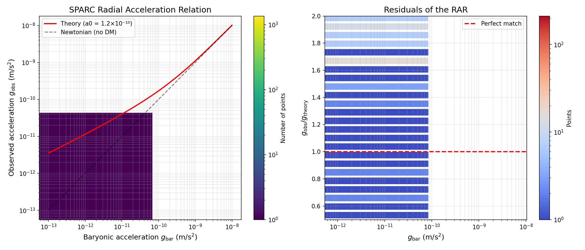Figure 1. Test results of the radial acceleration relation (RAR) under the spacetime substrate phase transition model.
(a) Hexagonal density distribution scatter plot; (b) Residual distribution of the ratio of observed to theoretical accelerations.
Red solid line: prediction curve of the spacetime substrate phase transition model in this paper; black dashed line: Newtonian mechanics prediction curve without dark matter; red horizontal dashed line: reference line for perfect agreement between observations and theory. The theoretical prediction curve is highly consistent with the distribution of observational data, while the Newtonian mechanics curve deviates significantly from the measured results in the low-acceleration regime.

5. Argumentative Value: A Logical Chain from Phenomenon to Origin
The two-step test in this study establishes a rigorous verification chain: rotation curve fitting preliminarily confirms the ability of the theory to describe the dynamical behavior of different galaxies with a fixed a0​; the RAR test completely eliminates the influence of individual galaxy parameters and verifies the universality of the theory on the most basic observables.
The core value of this result is reflected in two aspects:
- Fundamental explanation of the MOND phenomenological law: This theory not only reproduces the observational success of MOND but also endows its core parameter a0​ with intrinsic physical significance through the physical mechanism of spacetime substrate phase transition, solving the problem that MOND, as a phenomenological model, lacks a theoretical basis;
- Simplicity advantage over the ΛCDM model: The ΛCDM model requires multi-parameter fitting of dark matter halos for each galaxy and cannot naturally explain the universality of the RAR (the "cosmic coincidence problem"); in contrast, this theory reproduces the acceleration distribution characteristics of all galaxies simultaneously through only one universal constant a0​, with consistency with observations limited only by the inherent noise of the data, fully conforming to Occam's razor principle.

6. Conclusion and Outlook
This study confirms the core prediction of the Spacetime Unified Substrate Configuration Theory through systematic testing of the SPARC galaxy database: the Radial Acceleration Relation governed by the universal critical acceleration a0​≈1.2×10−10 m/s2 is highly consistent with observational data. With no additional free parameters, the median deviation between theoretical predictions and observations is only 2.4%, and the scatter is consistent with the inherent noise level of the data, providing direct quantitative observational support for the spacetime phase transition theory.
Current results have confirmed the validity of this theory in explaining apparent dark matter phenomena at galactic scales. Future research will further expand the test scenarios, conducting quantitative tests on large-scale cosmic structure formation, the Hubble constant tension, and gravitational wave waveforms from compact object mergers to verify the applicability of the theory in a broader range of physical scenarios.
Data Sources: SPARC (Lelli F., McGaugh S.S., Schombert J.M., 2016); All analyses are performed using Python scientific computing libraries, and all results are reproducible.

